Slacker Hacker

horizontal line



Vuong Nguyen, Luke Dercher, Luke Weber, Dylan Egnoske, Sri Gayatri Sundar

|  |  |
| --- | --- |
| Introduction | 2 |
| Installation Of Finished Slacker Hacker | 3 |
| Installation of Developer Slacker Hacker | 4 |
| Blocking Sites | 4 |
| Start Studying | 5 |
| To-do List | 6 |
| Graphs | 7 |
| Understanding The graphs | 8 |
| Sharing the graphs | 9 |
| Developer | 9 |
| Sources: | 9 |

# 

# Introduction

This Document Provides instruction on installation and use of Slacker Hacker, a Chrome™ extension used to help improve a person's productivity while using Google’s browser. This Document also provides information on developing from the existing code base of Slacker Hacker.

As of writing this document this product has not been integrated into the chrome web store, and to install this product follow the installation of developer Slacker Hacker section.

# Installation Of Finished Slacker Hacker

1. Open up a Chrome™ browser.
2. In the omnibox type <https://chrome.google.com/webstore/category/extensions>
3. In the search bar* type Slacker Hacker
   1. *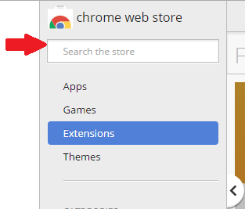
4. On the Hacker Slacker extension click the add to chrome button
   1. 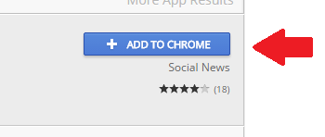
5. On the Popup click add to chrome

### **Congratulation! You have successfully installed SLACKER HACKER!**

# **Installation of Developer Slacker Hacker**

1. Download the repo from <https://github.com/degnoske/EECS448_Project_03>
2. Open up a Chrome™ browser and enter chrome://extensions/ into the omnibar
3. Click the developer mode button
   1. 
4. Click the Load unpacked extension
   1. 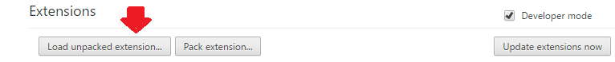
5. Choose the studytracker folder from the repo downloaded in step 1

### **Congratulation! You have successfully installed SLACKER HACKER!**

# Blocking Sites

The first thing you must do to use Slacker Hacker effectively you must block all sites you deem to be “time wasters” e.g. Facebook.

To block sites

1. open up a new tab.
2. Scroll until you reach the blacklist portion.
   1. 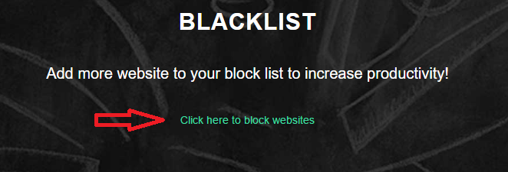
3. Click the link.
4. Enter the domain of a site you want blocked and press submit
   1. 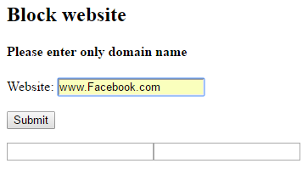

# Start Studying

The purpose of this extension is to help you with better study habits, in two ways.

1. Ensure that sites you deem unproductive are “blocked” or at least remind you, you should be studying.
2. Keep track of your studying time habits to help you improve your habits.

Both of these ways won't work unless you start the study timer.

To start the study timer:

1. Click on the extension popup in the upper right hand of the browser.
   1. 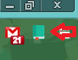
2. This will open a dropdown
   1. 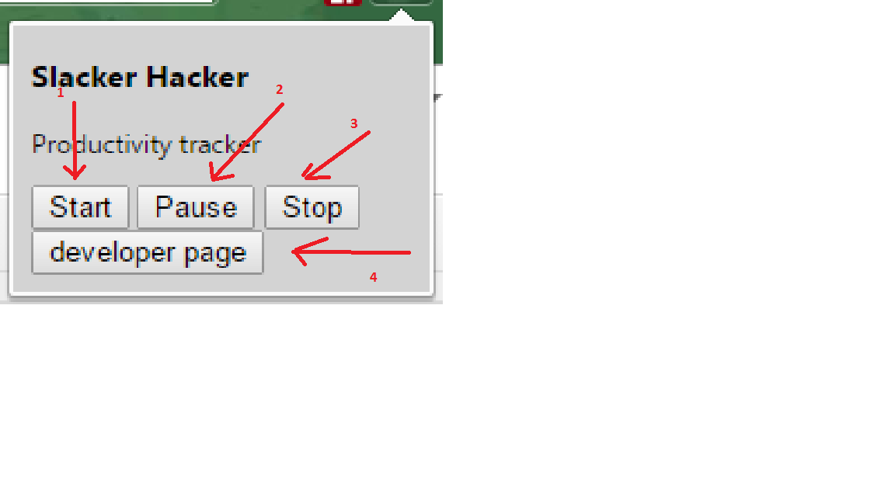

1. Clicking ‘Start’ starts the study timer. This will keep track of time spent studying and time spent on sites you decide to “block”.

2. Clicking ‘Pause’ pauses the timer.

3. Clicking ‘Stop’ stops the timer.

4. If you have downloaded and installed the developer version you will see a developer page button. This is discussed in further detail in the developer section.

# **To-do List**

To do lists are import for productivity. If you open up a new tab in your browser and scroll down you should find your todo list.

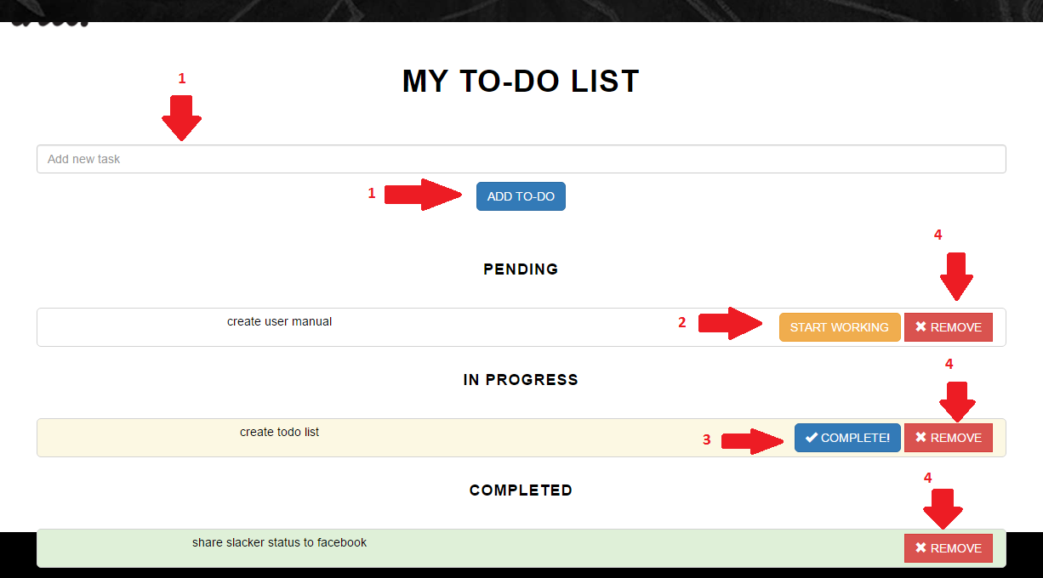

1. To add something to you list enter the new task in add new task text box and then click add to-do
2. To start working on a task click start working on any pending task
3. After finishing a task click the complete button
4. At any point you can remove a task by clicking the remove.

# **Graphs**

Understanding where you spend your time browsing is a great way to increase your studying productivity. If you scroll to the Graphs section on your new tab page you will find graphs detailing your times.

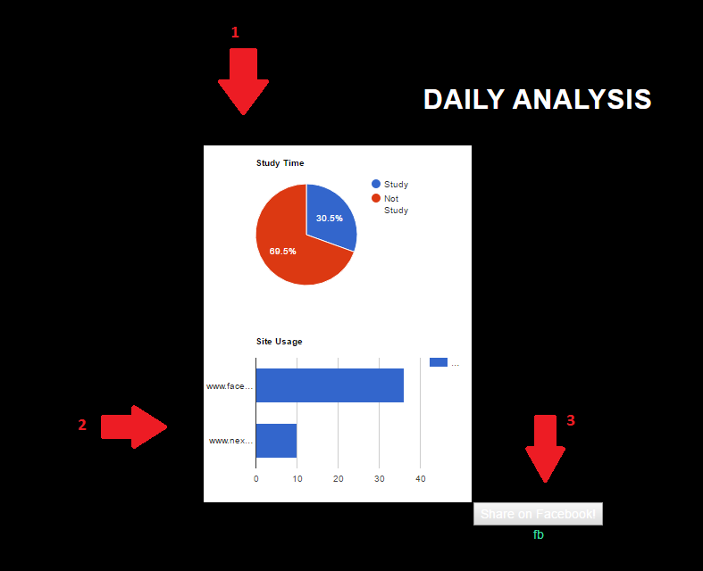

## Understanding The graphs

Both graphs keep track of your study time (seconds) in various ways.

1. The top graph is a pie chart detailing time spent studying and time spent not studying (time on sites you have blocked)
2. The bottom graph is a bar graph of time on sites that are blocked by you.

## Sharing the graphs

For motivational purposes or any other reason you can share your productivity graphs on facebook by clicking on the share facebook button (Number 3 in picture on page 7).

# Developer

See developer installation first.

Under start studying section 1 a you will see an example of the popup from the extension. If you click on the developer page you will be brought to the developer page. This page runs tests to ensure that the functions included in Slacker Hacker are working properly.

This page also contains a function for clearing local storage of all of the studying timers.

## Sources:

1. Use of the GNU open source license. Any addition to Slacker Hacker also has to follow all rules when using GNU. <http://www.gnu.org/licenses/gpl.html>
2. Google charts. <https://developers.google.com/chart/>
3. XML <http://www.w3.org/1999/xhtml>
4. AJAX and angular js <https://ajax.googleapis.com>
5. Firebase and Angular fire https://cdn.firebase.com